Assignment 1

By Duran Moodley

# Game Description

“Word Maker” is a word game that tests your word making skills. The aim of the game is to make a word using letters that will fall/trickle from the top of the screen. Random letters will be generated. The user can select a letter by tapping it before it reaches the end of the screen. The player cannot deselect a letter. Selecting the letter will save it in the word making section of the screen. Once the player has created a word, clicking on the add word button will add this word to the word list. The player will have a restricted amount of time to make as many words as possible. After the time has ended, the word will be validated to see if it exists. Every word that the user gets correct, he/she will get 20 points per word.

# Programming Tools Used

* Use an API to check if the word exists
* Read and write to a text file (player words created)
* Make use of the animation class
* Using Threads and Async Task
* Incorporating Fragments in an activity
* Making use of classes such as Factory class
* Making use of the XML component in android(Strings and Styles)

# How the Program works

The user will first be presented with a splash screen followed by the menu options. These options include: Play Game, How to play, History and About us.

The how to play option, provides a detailed description of how to play the game.

The History option contains a tab which consists of a user score section and the words created section. After every game play, the users score is written to a text file. This information is then displayed on the user score section as well as the Date and time that the user achieved that score. Furthermore, another text file stores all the valid words that the user has created.

The about us option, gives details about the developer of the game and other information that might interest the user.

The play game option allows the user to play the actually game has described in the game description section of this document. After the time has expired, the user will be presented with a message of their results. This include the amount of words got correct and the score that the user achieved. The user will also be presented with a button to play again.

# Screen shots

Icon and name of the game Splash screen of the game consisting of a progress bar.

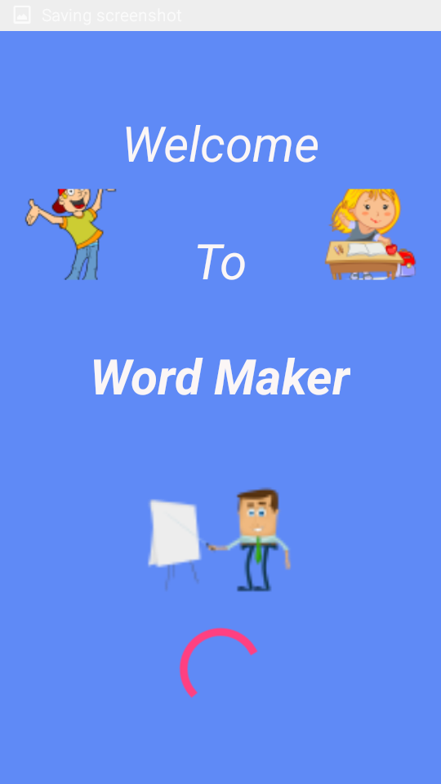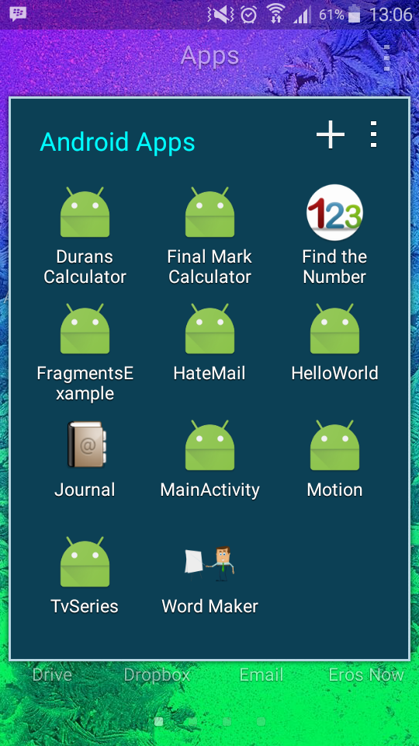

Menu screen displaying a set of options to the user.

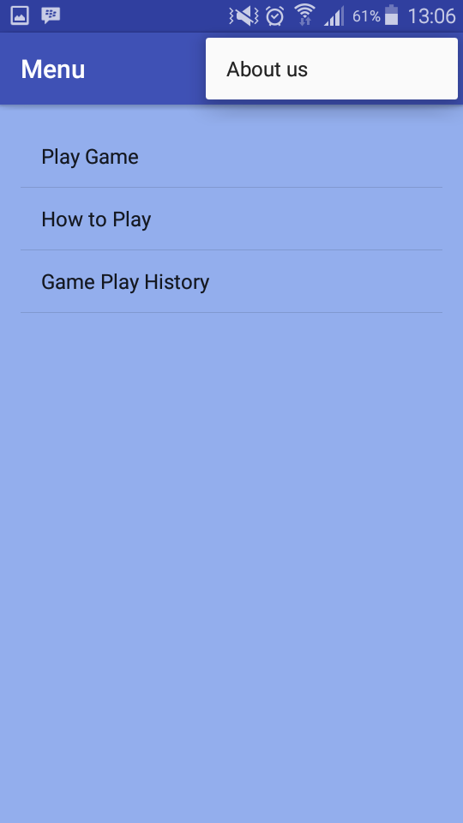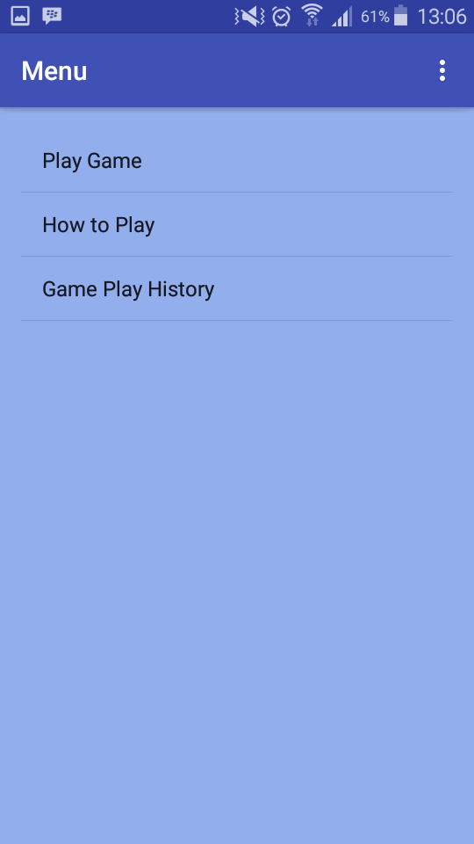

How to play screen, providing details/instructions. Provides details about the developer and game.

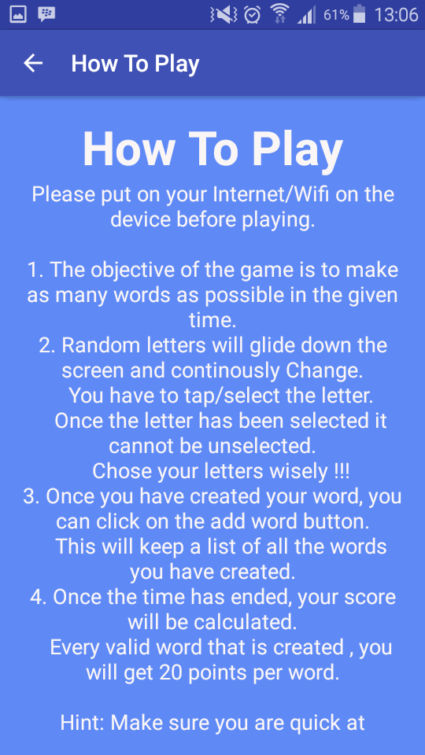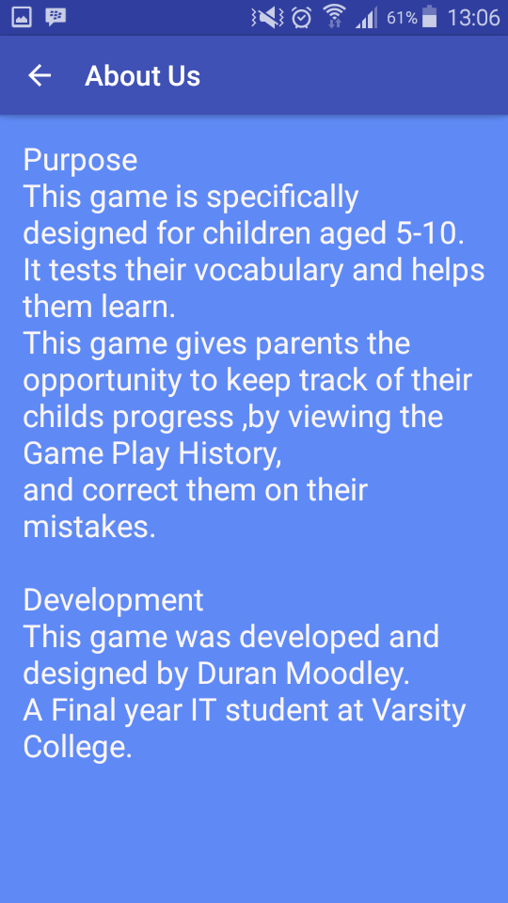

History – Scores of the user History – User words created

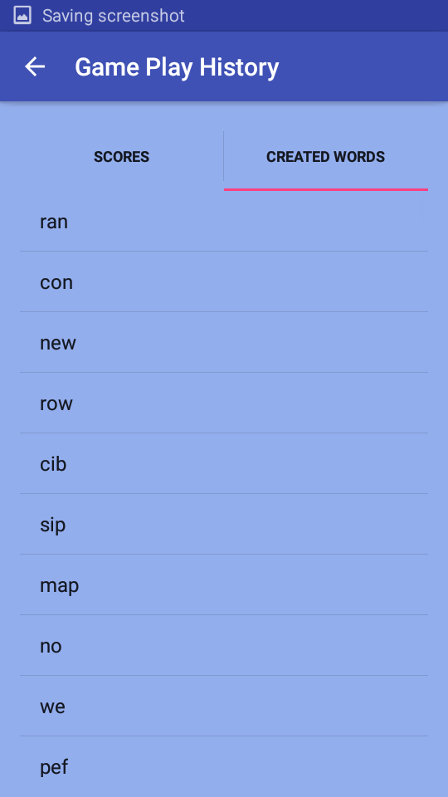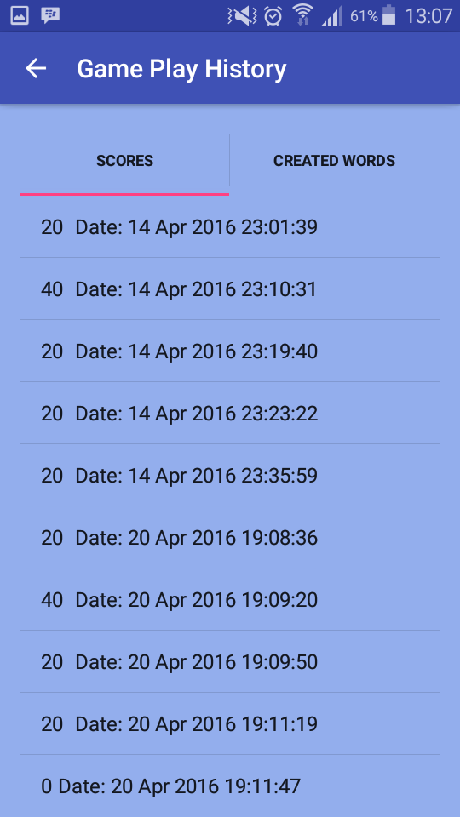

Game starts and countdown begins. Letters randomly generate. User has selected Selected a letter to use to create a word.

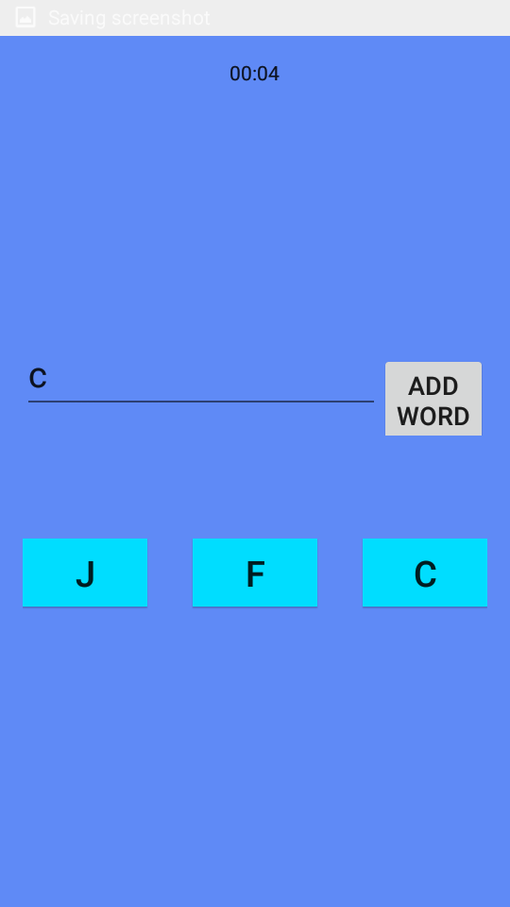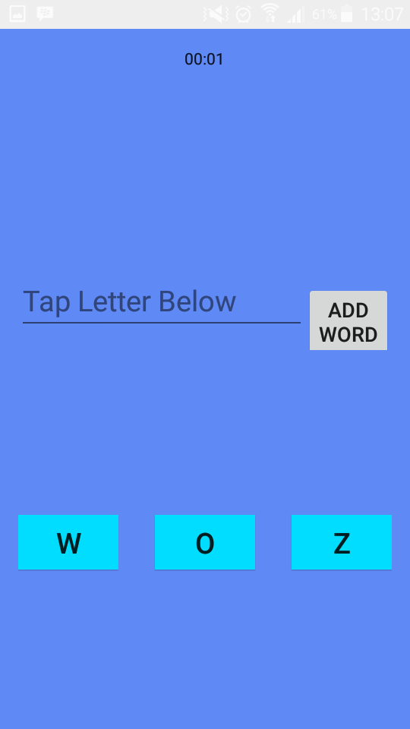

User has created a word and added it to the list by Time has expired. User result is displayed.

Clicking on the add word button. User can chose to play again or not.

